UNIT 3: Operators
Lessons:
- Arithmetic Operators
- Assignment Operators
- Increment and Decrement Operators
- Relational Operators
- Logical Operators
- Bitwise Operators
- Operator Precedence and Associativity
Module Assessment:
- Expression evaluation
- Simple calculator program

Operator :
Operators in C are symbols that perform operations on variables and values. Let me provide a comprehensive overview of all operator types in C.

1. Arithmetic Operators
Arithmetic operators are used to perform mathematical operations.
Operator | Description | Example
+ | Addition | a + b
- | Subtraction | a - b
* | Multiplication | a * b
/ | Division | a / b
% | Modulus (remainder) | a % b

Code :
#include <stdio.h>
int main() {
int a = 10, b = 3;
printf("Addition: %d\n", a + b);
printf("Subtraction: %d\n", a - b);
printf("Multiplication: %d\n", a * b);
printf("Division: %d\n", a / b);
printf("Modulus: %d\n", a % b);
return 0;
}
2. Assignment Operators
Assignment operators are used to assign values to variables.

Description | Example | Equivalent to
Simple assignment | a = b | a = b
Add and assign | a += b | a = a + b
Subtract and assign | a -= b | a = a - b
Multiply and assign | a *= b | a = a * b
Divide and assign | a /= b | a = a / b

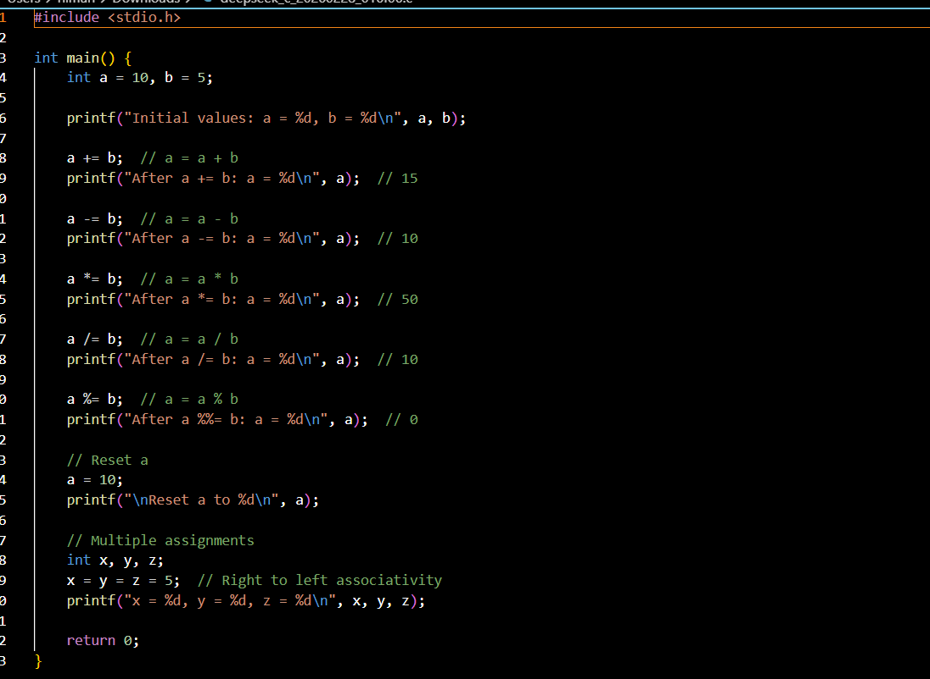

Increment and Decrement Operators in C
Increment and Decrement operators are unary operators. They operate on a single variable and increase or decrease its value by 1.
They are commonly used in:
- Loops
- Array indexing
- Pointer operations
- Counters
1. Increment Operator (++)
The increment operator increases the value of a variable by 1.
Types of Increment
a) Pre-Increment (++a)
The value is increased first, then used in the expression.
Syntax:
++variable; // Pre-increment
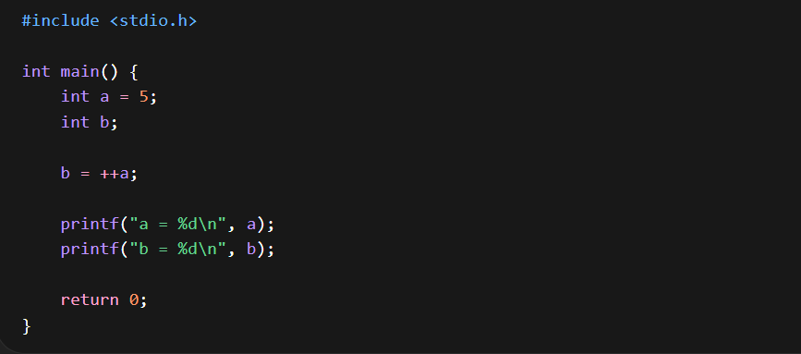
Output : a = 6 , b = 6
Explanation:
- a becomes 6 first.
- Then 6 is assigned to b.
b) Post-Increment (a++)
The current value is used first, then it is increased.
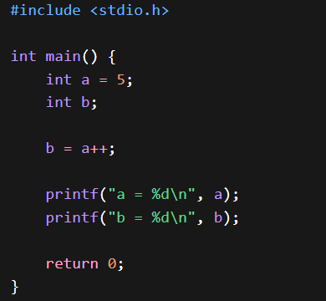

a = 6
b = 5
Explanation:
- Old value (5) is assigned to b.
- Then a becomes 6.

2. Decrement Operator (--)
The decrement operator decreases the value of a variable by 1.
Syntax:
--variable; // Pre-decrement
variable--; // Post-decrement
A. Pre-Decrement (--a)
Value decreases first, then used
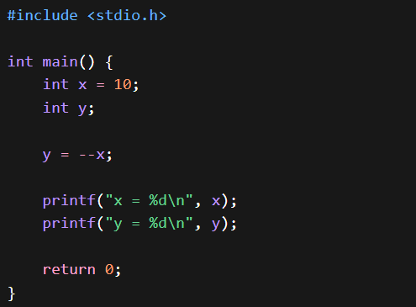
Output :
x = 9
y = 9

B. Post-Decrement (a--)
Value used first, then decreased.
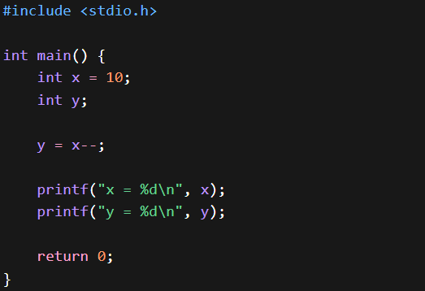
x = 9
y = 10
Relational Operators in C – Detailed Notes
Relational operators in C are used to compare two values, variables, or expressions. These operators help us determine the relationship between two operands. The result of a relational operation is always either true or false.
In C language:
- True is represented by 1
- False is represented by 0
Relational operators are mainly used in:
- Conditional statements (if, if-else)
- Loops (for, while, do-while)
- Decision-making programs
- Comparing values in arrays and user input

List of Relational Operators:

Operator | Meaning
< | Less than
> | Greater than
<= | Less than or equal to
>= | Greater than or equal to
== | Equal to
!= | Not equal to

1. Less Than Operator (<)
The less than operator checks whether the left operand is smaller than the right operand.
If the condition is true, it returns 1. Otherwise, it returns 0.
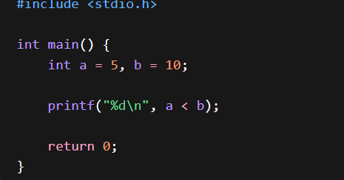
Explanation:
Since 5 is less than 10, the output will be 1.
2. Greater Than Operator (>)
The greater than operator checks whether the left operand is greater than the right operand.
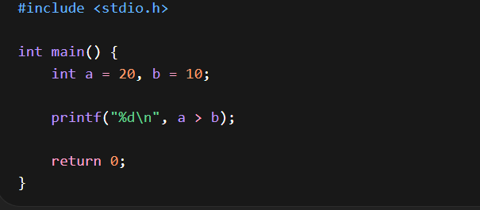
Explanation:
Since 20 is greater than 10, the output will be 1.
3. Less Than or Equal To (<=)
This operator checks whether the left operand is either less than or equal to the right operand.
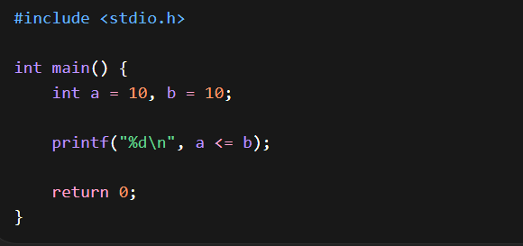
Explanation:
Since 10 is equal to 10, the condition is true. Output will be 1.
4. Greater Than or Equal To (>=)
This operator checks whether the left operand is greater than or equal to the right operand.
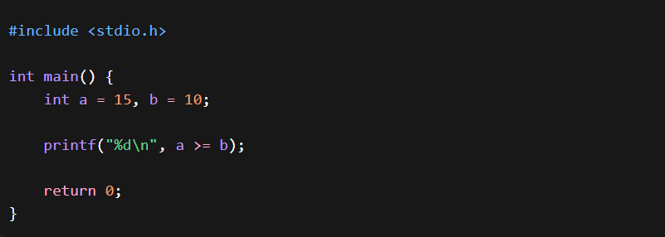
Explanation:
15 is greater than 10, so the output is 1.
5. Equal To (==)
The equal to operator checks whether two values are equal.
Important:
== is used for comparison.
= is used for assignment.
Many beginners confuse these two.
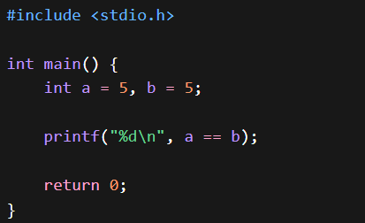
Explanation:
Since both values are equal, output is 1.
6. Not Equal To (!=)
The not equal operator checks whether two values are not equal.
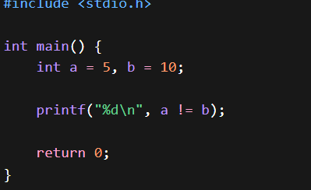
Explanation:
Since 5 and 10 are not equal, the output will be 1.
Bitwise Operator:
Bitwise operators in C are used to perform operations at the binary (bit) level. These operators work directly on the bits of integer data types such as int, char, short, and long.
Unlike arithmetic operators, which work on whole numbers, bitwise operators manipulate individual bits (0 and 1).
Bitwise operators are mainly used in:
- System programming
- Embedded systems
- Device drivers
- Low-level hardware interaction
- Optimizing memory usage
- Performing fast mathematical operations

Binary Number System (Basic Understanding)
Before learning bitwise operators, you must understand binary representation.
Decimal 5 = 00000101
Decimal 3 = 00000011

1. Bitwise AND (&)
The AND operator compares each bit of two numbers.
It returns 1 only if both bits are 1.
A | B | A & B
0 | 0 | 0
0 | 1 | 0
1 | 0 | 0
1 | 1 | 1

5 = 0101
3 = 0011
-------------
5 & 3 = 0001 (Decimal 1)
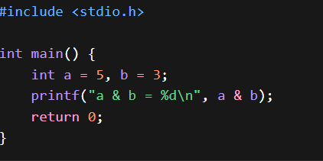
a & b = 1
2. Bitwise OR (|)
The OR operator returns 1 if at least one bit is 1.
Truth Table:
| A | B | A | B |
|---|---|------|
| 0 | 0 | 0 |
| 0 | 1 | 1 |
| 1 | 0 | 1 |
| 1 | 1 | 1 |
5 = 0101
3 = 0011
-------------
5 | 3 = 0111 (Decimal 7)
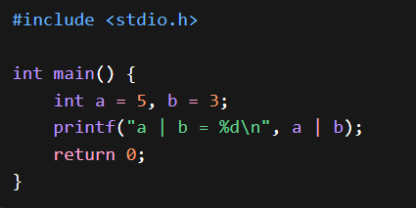
3. Bitwise XOR (^)
The XOR operator returns 1 only if the bits are different.
A | B | A ^ B
0 | 0 | 0
0 | 1 | 1
1 | 0 | 1
1 | 1 | 0

Code:
5 = 0101
3 = 0011
-------------
5 ^ 3 = 0110 (Decimal 6)

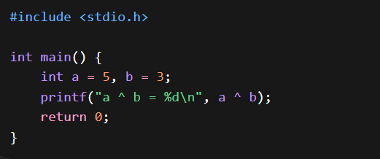
Important Concepts
- Bitwise operators work only on integer data types.
- They operate at the binary level.
- They are faster than arithmetic operations in some cases.
- Shift operators are commonly used for multiplication and division by powers of 2.
- Understanding binary representation is very important.

Operator Precedence and Associativity :
Operator precedence and associativity are important concepts in C that determine how expressions are evaluated when multiple operators are used in a single statement.
When writing complex expressions, C must decide:
- Which operator should be evaluated first?
- If operators have the same precedence, in which direction should evaluation occur?
These decisions are made using precedence and associativity rules.
1. Operator Precedence
Operator precedence defines the priority level of operators in an expression.
Operators with higher precedence are evaluated before operators with lower precedence.
Eg : int result = 10 + 5 * 2;
Multiplication (*) has higher precedence than addition (+).
So the expression is evaluated as:
10 + (5 * 2)
First:
5 * 2 = 10
Then:
10 + 10 = 20
Final result = 20

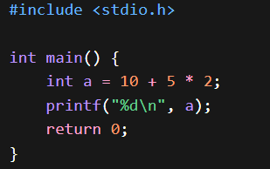
Example With Parentheses
Parentheses have the highest precedence.
int a = (10 + 5) * 2;
Now evaluation becomes:
(10 + 5) = 15
15 * 2 = 30
Output = 30
Parentheses are used to override default precedence.
2. Operator Associativity
Associativity determines the direction in which operators of the same precedence are evaluated.
There are two types:
- Left to Right associativity
- Right to Left associativity

Left to Right Associativity
Most operators in C follow left to right associativity.
Example:
int a = 20 / 5 * 2;
Division and multiplication have same precedence.
Evaluation happens from left to right:
20 / 5 = 4
4 * 2 = 8
Final result = 8

Right to Left Associativity
Assignment operators follow right to left associativity.
Example:
int a, b, c;
a = b = c = 10;
Evaluation happens from right to left:
c = 10
b = c
a = b
All variables become 10.
3. Complete Operator Precedence Table (High to Low)
Precedence Level | Operators | Associativity
1 (Highest) | () [] -> . | Left to Right
2 | ++ -- (unary) sizeof ! ~ | Right to Left
3 | * / % | Left to Right
4 | + - | Left to Right
5 | << >> | Left to Right
6 | < <= > >= | Left to Right
7 | == != | Left to Right
8 | & | Left to Right
9 | ^ | Left to Right
10 | | | Left to Right
11 | && | Left to Right
12 | || | Left to Right
13 | ?: | Right to Left
14 | = += -= *= /= %= | Right to Left
15 (Lowest) | , | Left to Right

4. Practical Example
Consider this expression:
int x = 5 + 2 * 3 > 10 && 4;
Step-by-step evaluation:
- Multiplication: 2 * 3 = 6
- Addition: 5 + 6 = 11
- Relational: 11 > 10 = 1
- Logical AND: 1 && 4
In logical AND:
Any non-zero value is treated as true.
So:
1 && 4 = 1
Final value of x = 1
5. Important Rules
- Parentheses always have highest priority.
- Unary operators have higher precedence than arithmetic operators.
- Multiplication and division have higher precedence than addition and subtraction.
- Relational operators have lower precedence than arithmetic operators.
- Logical operators have lower precedence than relational operators.
- Assignment operators have very low precedence.
- When operators have equal precedence, associativity decides the direction.
6. Common Mistakes
Mistake 1: Forgetting parentheses
int a = 10 - 5 - 2;
Evaluation (Left to Right):
(10 - 5) - 2 = 3
Not:
10 - (5 - 2)
Mistake 2: Confusing assignment and equality
if (a = 5)
This assigns 5 to a, not compares.
Correct:
if (a == 5)
7. Why Precedence Matters
Incorrect understanding of precedence can:
- Produce wrong output
- Create logical errors
- Make code difficult to debug
To avoid confusion:
Always use parentheses in complex expressions.
Example:
Instead of:
int result = a + b * c - d / e;
Write:
int result = (a + (b * c)) - (d / e);
This improves clarity.

